
PROJECT REPORT
ON
CYBER CRIME CASE MANAGEMENT SYSTEM
Degree of Bachelor of Technology
In
Computer Science and Engineering (AIML)
By

NAME: TANISHKA JOSHI
REGISTRATION NUMBER: 25BAI10767
Academic Year: 2026–27
INTRODUCTION
With the internet and digital services now part of everyday life, cyber crime has unfortunately become all too common. From online fraud and phishing scams to account hacking, identity theft, and cyber bullying, there's a growing need to track and manage these cases properly.

This project aims to build a straightforward system that brings all the pieces of a cyber crime case together in one place. Rather than scattering case details, evidence, and investigator information across different files or notes, the application keeps everything organized and easy to access.

Built using Java, the system leans heavily on object-oriented programming principles to keep the code clean and modular. It also uses file handling to store data, so nothing gets lost when the program closes—everything stays saved and ready for the next time you need it.

What makes this system useful is its focus on simplicity and practicality. It's designed to be easy to use, even for people who aren't tech experts, while still providing enough structure to handle real-world case management needs. By centralizing information, the system helps investigators work more efficiently, reduce errors, and maintain a clear record of every case from start to finish.
In a world where cyber threats keep evolving, having a reliable way to document and monitor cases isn't just helpful—it's essential. This project is a small step toward building that kind of reliability, using solid programming practices to make a real difference in how cyber crime cases are handled.
PROBLEM STATEMENT
As the number of cyber crime cases grows, managing everything manually quickly becomes overwhelming. Paper files, scattered spreadsheets, or random notes make it easy to lose track of critical details—like victim information, current case status, evidence logs, or which investigator is handling what. Important updates get missed, files go missing, and valuable time is wasted just trying to find the right information.
The proposed system offers a simple, computerized way to bring order to this chaos. It lets users register new cases, search through existing ones, update details as investigations progress, and monitor overall case status—all from one place. Instead of mixing everything together, the system stores evidence and investigator information in separate, organized sections, then links them to the right case when needed. This keeps things tidy and makes it much easier to pull up exactly what you need, when you need it.
Beyond just storing data, the system is built to support real investigative work. It reduces the risk of human error, speeds up information retrieval, and ensures that nothing falls through the cracks as cases move forward. For teams dealing with dozens or even hundreds of cases, this kind of structure isn't just convenient—it's a necessity for staying on top of the workload and delivering results.

FUNCTIONAL REQUIREMENT

Module 1 — Case Management
The user can:
- Register a new case
- View all cases
- Search a case
- Update case status

Module 2 — Evidence Management
The user can:
- Add evidence
- Link evidence with a case
- View stored evidence

Module 3 — Investigator Management
The user can:
- Add investigator details
- Store department information
- View investigators

Module 4 — Monitoring & Statistics
The system can:
- Count total cases
- Count cases by status
- Display basic case statistics

NON FUNCTIONAL REQUIREMENT

  - Usability
The menu is kept straightforward and intuitive, so anyone can start using the system with little to no training.
  - Reliability
Case information is saved properly to files, ensuring that nothing gets lost when the program closes or the system restarts.
  - Security
A basic login screen protects the dashboard, so only authenticated users can access sensitive case data.
  - Maintainability
The code is organized into separate classes for different functions, making it easier to update, debug, or extend in the future.
  - Error Handling
Instead of crashing on bad input, the program validates what the user enters and shows clear, helpful error messages.
  - Resource Efficiency
The system runs lightweight, using basic Java collections and text files rather than demanding a heavy database setup—making it easy to deploy even on modest hardware.

ALGORITHM
1. Launch the app and show the login screen.
2. Check the username and password. If they're wrong, show an error and exit.
3. On successful login, open the main dashboard.
4. Let the user pick an action:
- Register a new case
- View all cases
- Search for a case
- Update case status
- Add or view evidence
- Add or view investigators
- View case statistics
5. For registration, collect Case ID, crime type, victim name, and description; create a case object and save it to cases.txt.
6. For search, take a Case ID, match it against stored records, and show details if found.
7. For evidence, gather details plus the Case ID and save to evidence.txt.
8. For investigators, collect their info and save to investigators.txt.
9. For statistics, count cases by status and display the breakdown.
10. Write any updates back to the appropriate text files.
11. Loop back to the dashboard until the user chooses Exit, then close the program.
FLOWCHART
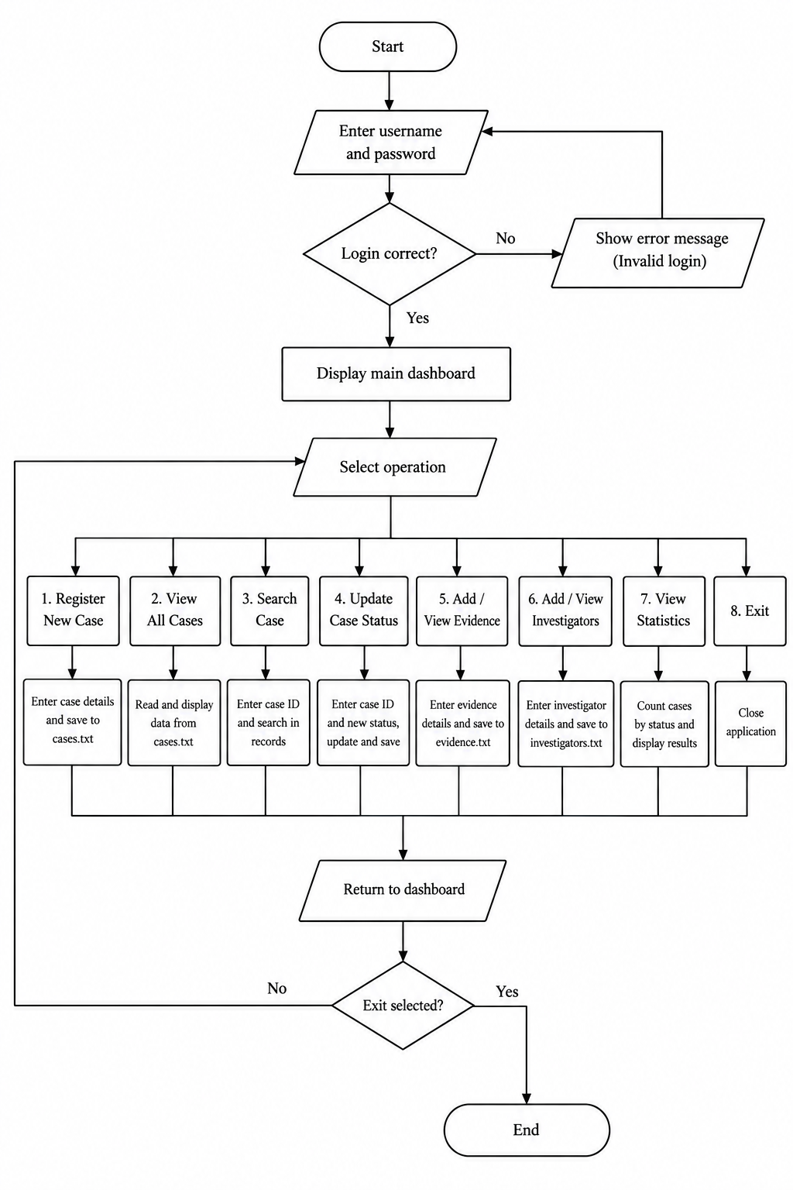
UPPER CASE DIAGRAM
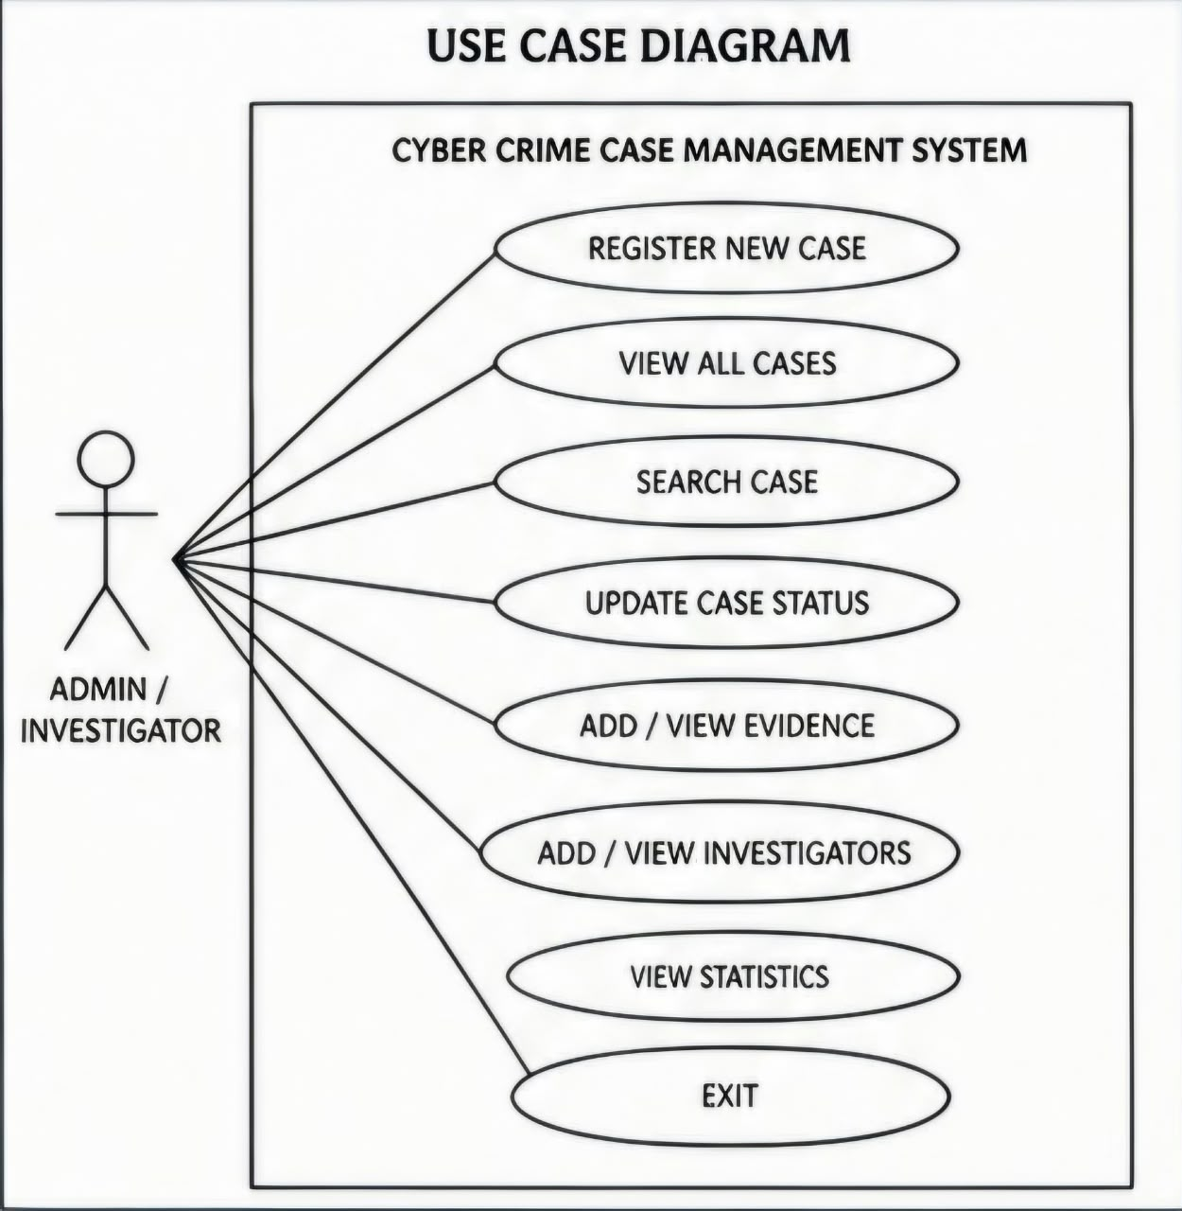
WORK FLOW DIAGRAM
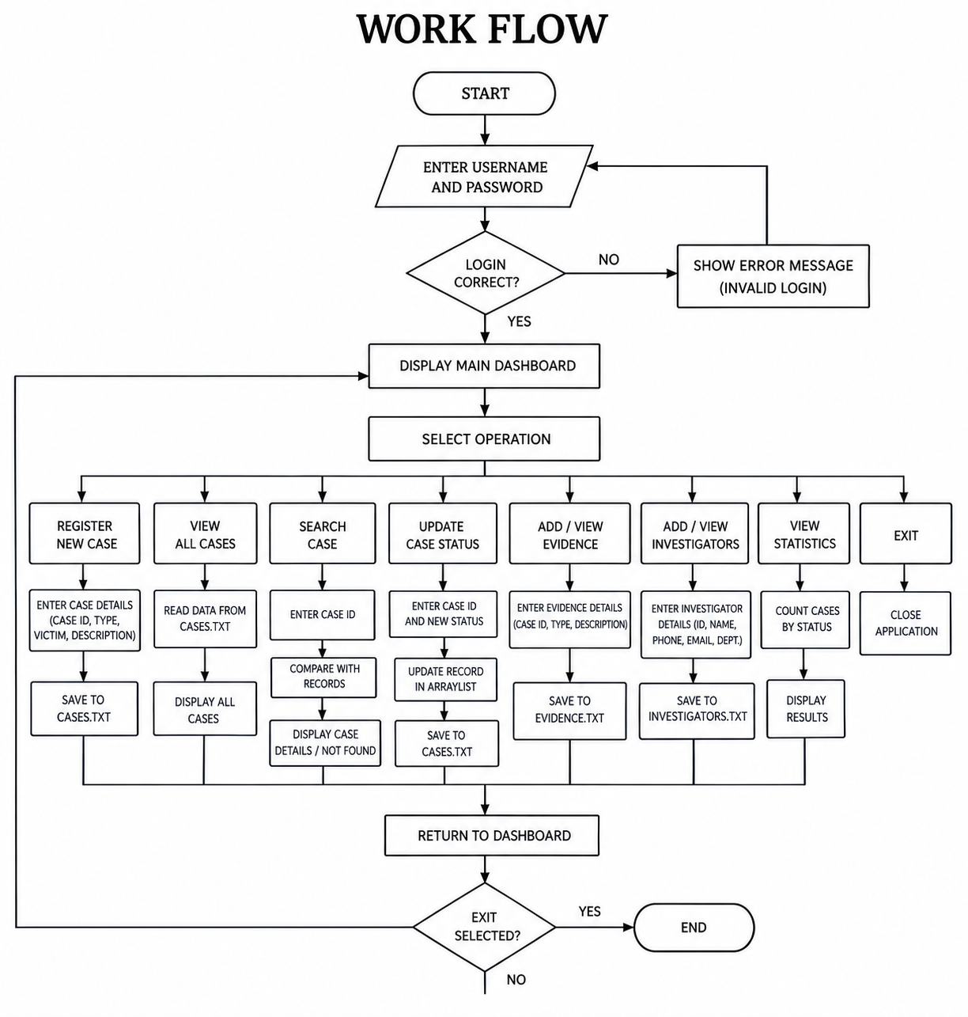
SEQUENCE DIAGRAM
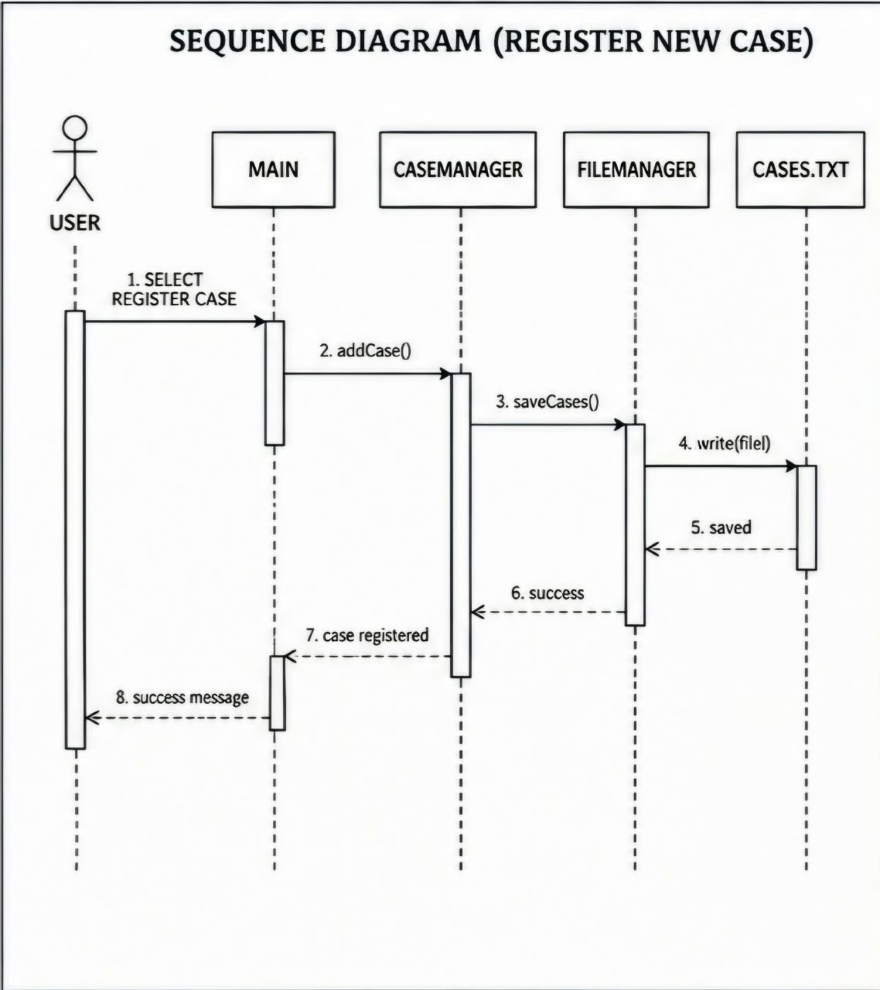
SYSTEM ARCHITECTURE
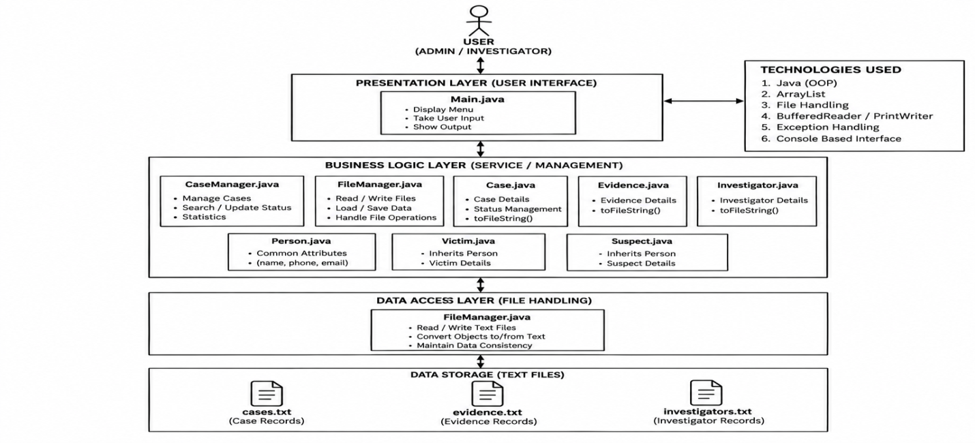
OUTPUT SCREENSHOTS
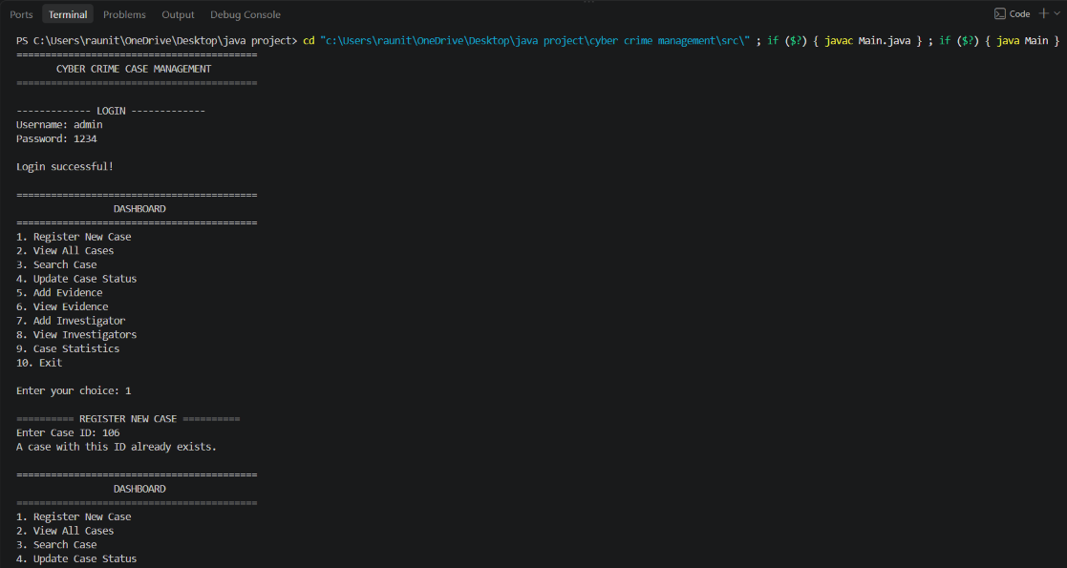
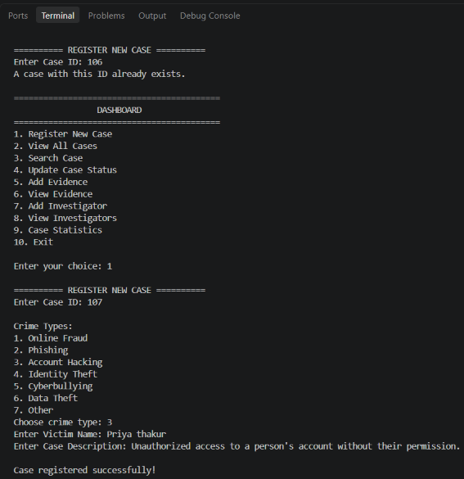

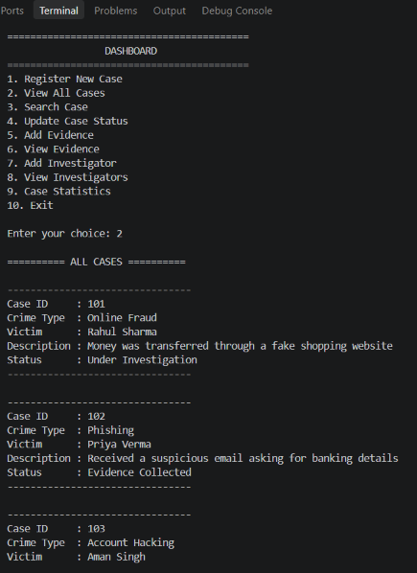

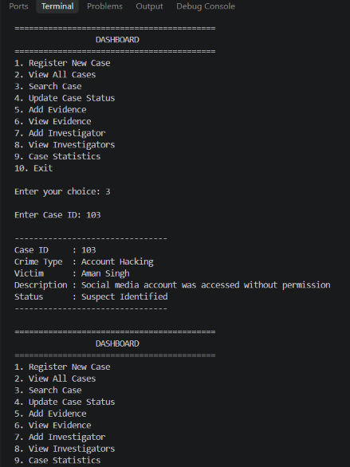
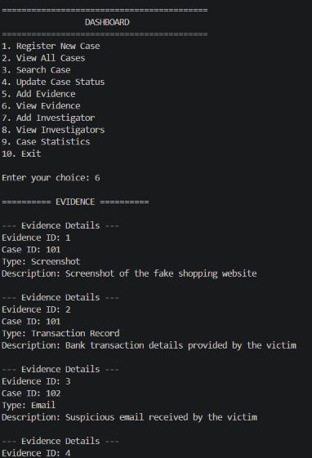

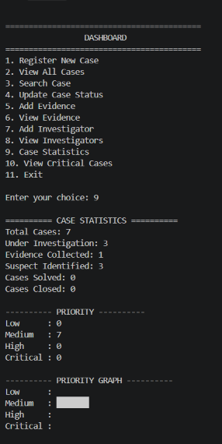
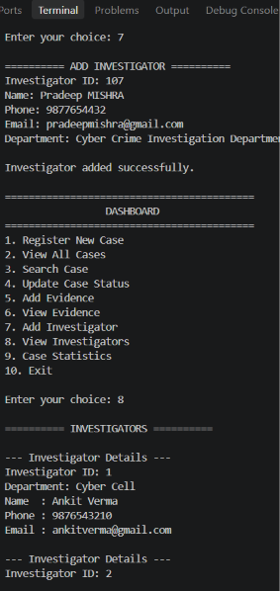

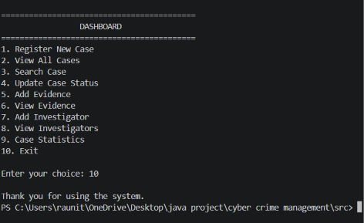
DESIGN DECISIONS & RATIONALE
While building the Cyber Crime Case Management System, I made several design choices to keep it simple, organized, and practical—guided by the project's goals and core Java concepts.
      - Using Java for Development
Java was the natural choice to apply object-oriented programming in practice. Its built-in support for classes, collections, exception handling, and file I/O made it ideal for this system.
- Dividing the Project into Classes
The code is split into focused classes like Case, Evidence, Investigator, CaseManager, and FileManager. This keeps things modular and easy to maintain—changes stay isolated to the relevant class.
- Using Text Files for Storage
Data is saved in simple text files (cases.txt, evidence.txt, investigators.txt). For a small academic project, this avoids database complexity while demonstrating file handling in Java.
- Using Array List for Records
Array Lists store cases, evidence, and investigators during runtime. They're flexible for dynamic data and make adding, searching, and displaying records straightforward.
- Separating Case Management
All case operations live in the Case Manager class, not Main.java. This keeps the entry point clean and the logic easier to follow.
- Adding a Login System
A basic username/password login guards the dashboard. It's simple for this project but illustrates the need for authentication in real systems.
- Menu-Based Console Interface
A text-based menu lets users register cases, search, add evidence, and more—without GUI overhead. This kept the focus on Java logic and OOP design.
- Linking Evidence to Cases
Each evidence record includes a Case ID, clearly tying it to the right case. This supports one-to-many relationships cleanly.
- Tracking Case Status
Statuses like Under Investigation, Evidence Collected, and Case Closed give a quick view of each case's progress.
- Designing for Future Growth
The modular structure means features can be added later—like swapping text files for a database or adding a GUI. This version is a solid foundation to build on.
IMPLEMENTATION DETAILS
The Cyber Crime Case Management System is implemented in Java using object-oriented programming concepts. The application is divided into separate classes to keep the code organized and easy to maintain.
IMPLEMENTATION FLOW
Login → Dashboard → Select Operation
→ Process Case/Evidence/Investigator
→ Save/Read Data
→ Display Result

Technologies Used
- Language: Java
- IDE: Visual Studio Code
- Storage: Text files
- Data Structure: Array List
- Version Control: Git/GitHub

Main Components
- Main: Handles login and menu operations.
- Case: Stores case information.
- Case Manager: Performs case registration, searching and status updates.
- Evidence: Stores evidence details linked with a Case ID.
- Investigator: Stores investigator information.
- File Manager: Reads and writes data to text files.

Data Storage
The system uses three files:
      - cases.txt
      - evidence.txt
3.investigators.txt
.
FORMULA USED
Total Cases = Number of registered cases
Solved Case Percentage = (Solved Cases / Total Cases) × 100
Case Resolution Rate = ((Solved Cases + Closed Cases) / Total Cases) × 100

TESTING TABLE
Test | INPUT | Expected Result | Result
Login | admin / 1234 | Login successful | Pass
Wrong Login |  | Login rejected | Pass
  abc / 123
Register Case | Case 105 | Case saved | Pass
Search Case | 102 | Case 102 displayed | Pass
Search Invalid Case | 999 | Case not found | Pass
Add Evidence | Case101 | Evidence saved | Pass
Update Status | Case101 | Status changed | Pass
View Statistics | Option9 | Statistics displayed | Pass
CHALLENGES FACED
During development, one of the biggest hurdles was breaking the project down into clean, separate Java classes. Figuring out how each class should talk to the others—what data to pass, when to call methods, and how to keep responsibilities clear—took some trial and error before everything clicked.
File handling was another tricky part. The system needed to read existing case records, add new ones, and update details without accidentally overwriting or losing anything. Getting the read/write logic right, especially when dealing with multiple files for cases, evidence, and investigators, required careful testing.
Input validation also needed several rounds of refinement. A single wrong entry—like typing letters where numbers were expected—could break the menu flow or cause unexpected behavior. The program now checks inputs more thoroughly and guides users back on track with clear messages instead of crashing.
On top of that, organizing the project structure itself was a learning curve. Making sure all the Java files sat in the right places inside the src folder, and that the program could reliably find and open the text files it needed, involved quite a bit of debugging and path adjustments.

LEARNING & KEYS TAKE AWAYS
This project gave me a much clearer picture of how Java's OOP concepts work in a real application—not just in small, isolated examples. I learned how to break a big problem down into smaller, focused classes and make them work together smoothly.

I also got hands-on experience with Array Lists for managing collections of objects and saw how file handling can preserve data even after the program shuts down.

Perhaps most importantly, debugging taught me that even tiny issues—like a wrong file path or an unchecked user input—can ripple through the entire application. It was a good reminder that attention to detail matters just as much as writing the core logic.
FUTURE ENHANCEMENTS
            - Build a graphical user interface using Java Swing or JavaFX to make the system more intuitive and visually engaging.

            - Swap out text-file storage for a MySQL database to handle larger volumes of data more efficiently.

            - Introduce user roles like Admin and Investigator, so different users get access to different features based on their responsibilities.

      - Strengthen password security with encryption and hashing to protect sensitive login information.

      - Add automatic report generation so users can quickly produce summaries or detailed case reports.

      - Include charts and visual dashboards to display case statistics at a glance.

      - Enable date-based filtering to search or sort cases within specific time ranges.

      - Set up email notifications to alert investigators or admins when a case is updated.

      - Implement a backup and restore feature to safeguard data and recover it if something goes wrong.

In a more advanced version, explore adding a machine-learning module to automatically classify complaints or prioritize cases based on urgency or pattern recognition
REFERENCES

1. Oracle Java Documentation
2. Java Platform Documentation
3. VITyarthi – JAVA Course
4. GitHub Documentation
5. Course lecture notes and classroom material

CONCLUSION
The Cyber Crime Case Management System offers a straightforward, organized way to handle cyber crime cases, along with their associated evidence and investigator information. Throughout the project, core Java concepts—like OOP, inheritance, Array Lists, file handling, and exception handling—were put to work in a real, functional application.

Users can register new cases, search through existing ones, and update details while keeping all related records properly linked. Beyond just building a working system, the project deepened my understanding of how Java can tackle real-world problems. It also leaves plenty of room to grow—whether that's adding a database, building a graphical interface, or tightening up security for more robust, production-ready use.



